

# 

### Semester Two Examination, 2016

### Question/Answer Booklet

# MATHEMATICS

**APPLICATIONS**

**UNITS 1 AND 2**

## Section Two:

## Calculator-assumed

**Your name**

**Your teacher (circle one)** Foxton Hanna Hill Scorer Wallace

## Time allowed for this section

Reading time before commencing work: ten minutes

Working time for section: one hundred minutes

## Materials required/recommended for this section

***To be provided by the supervisor***

This Question/Answer Booklet

Formula Sheet (retained from Section One)

***To be provided by the candidate***

Standard items: pens (blue/black preferred), pencils (including coloured), sharpener, correction fluid/tape, eraser, ruler, highlighters

Special items: drawing instruments, templates, notes on two unfolded sheets of A4 paper, and up to three calculators approved for use in the WACE examinations

## Important note to candidates

No other items may be taken into the examination room. It is **your** responsibility to ensure that you do not have any unauthorised notes or other items of a non-personal nature in the examination room. If you have any unauthorised material with you, hand it to the supervisor **before** reading any further.

## Structure of this paper

|  |  |  |  |  |  |
| --- | --- | --- | --- | --- | --- |
| Section | Number of questions available | Number of questions to be answered | Working  time (minutes) | Marks available | Percentage of exam |
| Section One:  Calculator-free | 7 | 7 | 50 | 51 | 35 |
| Section Two:  Calculator-assumed | 13 | 13 | 100 | 99 | 65 |
|  | | | **Total** | 150 | 100 |

## Instructions to candidates

1. The rules for the conduct of examinations are detailed in the school handbook. Sitting this examination implies that you agree to abide by these rules.

2. Write your answers in this Question/Answer Booklet.

3. You must be careful to confine your response to the specific question asked and to follow any instructions that are specified to a particular question.

4. Spare pages are included at the end of this booklet. They can be used for planning your responses and/or as additional space if required to continue an answer.

* Planning: If you use the spare pages for planning, indicate this clearly at the top of the page.
* Continuing an answer: If you need to use the space to continue an answer, indicate in the original answer space where the answer is continued, i.e. give the page number. Fill in the number of the question that you are continuing to answer at the top of the page.

5. **Show** **all your working clearly**. Your working should be in sufficient detail to allow your answers to be checked readily and for marks to be awarded for reasoning. Incorrect answers given without supporting reasoning cannot be allocated any marks. For any question or part question worth more than two marks, valid working or justification is required to receive full marks. If you repeat any question, ensure that you cancel the answer you do not wish to have marked.

6. It is recommended that you **do not use pencil**, except in diagrams.

7. The Formula Sheet is **not** to be handed in with your Question/Booklet.

Section Two: Calculator-assumed 65% (99 Marks)

This section has**thirteen (****13)** questions. Answer **all** questions. Write your answers in the spaces provided.

Working time for this section is 100 minutes.

Question 8 (6 marks)

A worker in a chemical factory earns $42.70 per hour on a weekday, time and a half at weekends, and a fixed allowance of $39.15 per day.

(a) Calculate the workers' weekly pay when she works from 9 am until 1 pm and then 1.30 pm until 4.30 pm from Wednesday to Sunday inclusive. (4 marks)

(b) Calculate the workers' total holiday pay when she takes four weeks annual leave, if the company pays her for 35 hours per week at her base rate, does not pay the fixed allowance but does add leave loading of 17.5%. (Leave loading is 17.5% of the base rate of pay and is paid on top of the normal weekly earnings during annual leave.) (2 marks)

Question 9 (8 marks)

Sam and Tom recorded their daily exercise time over a two-week period. Their times are shown below to the nearest minute.

|  |  |  |  |  |  |  |  |  |  |  |  |  |  |  |
| --- | --- | --- | --- | --- | --- | --- | --- | --- | --- | --- | --- | --- | --- | --- |
| Sam | 29 | 27 | 30 | 28 | 27 | 28 | 31 | 31 | 25 | 32 | 26 | 27 | 32 | 26 |
| Tom | 27 | 24 | 25 | 26 | 27 | 23 | 28 | 26 | 29 | 25 | 27 | 29 | 26 | 29 |

(a) The left-hand side of the stem plot below displays the exercise times for Sam. Complete the right-hand side for the times that Tom exercised. (2 marks)

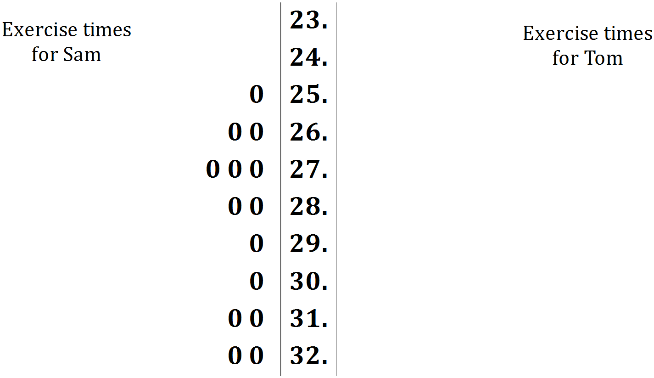

Key: **32.|0** means 32

(b) Calculate the mean of the times spent exercising for each person and explain how their difference relates to a feature of the stem plot. (3 marks)

(c) Calculate the standard deviations of the times spent exercising for each person and explain how their difference relates to a feature of the stem plot. (3 marks)

Question 10 (6 marks)

A semi-circular grassed area has a radius of 45 m.

(a) A fence is to be installed around the edge of the area at a cost of $85 per metre. Calculate the cost of fencing to the nearest hundred dollars. (3 marks)

(b) A rotunda (round building) is to be built in the middle of the grassed area with a hemispherical glass roof. The cost of the rotunda is $17 800 plus $235 per square metre for the glass used in the hemispherical roof. If the radius of the hemisphere is 4.5 m, calculate the cost of building the rotunda to the nearest hundred dollars. (3 marks)

Question 11 (7 marks)

A young couple purchased a house for $419 000 and sold it one year later for $432 000.

(a) Calculate the percentage profit they made. (2 marks)

(b) The couple financed their purchase of the house with an interest only loan of $336 000 at a rate of 4.85% pa. Calculate the simple interest payable for the first month. (2 marks)

(c) The couple used the services of a real estate agent to sell the house. The agent charged 2.5% of the selling price on the first $100 000 and 0.75% on the remainder. Calculate the agent's fee for selling the house. (2 marks)

(d) The agent bought advertising through an internet company for $423.50, including GST at 10%. How much of the advertising cost was GST? (1 mark)

Question 12 (7 marks)

Stalls at a pop-up market cost $60 per day. A student, who makes pairs of earrings that cost $5 each and sell for $11 each, hires a stall for a day.

(a) If the student sells $x$ pairs of earrings at the market one day, explain why

(i) the total cost for the day is given by $5x+60$. (1 mark)

(ii) the total revenue for the day is given by $11x$. (1 mark)

(b) Complete the table below to show the cost and revenue for the given values of $x$.

(2 marks)

|  |  |  |  |  |
| --- | --- | --- | --- | --- |
| $$x$$ | 0 | 6 | 12 | 18 |
| Total cost, $ | 60 |  |  |  |
| Total revenue, $ | 0 |  |  |  |

(c) Graph the two straight lines that represent the daily cost and revenue when the student sells $x$ pairs of earrings at the market on the axes below. (2 marks)

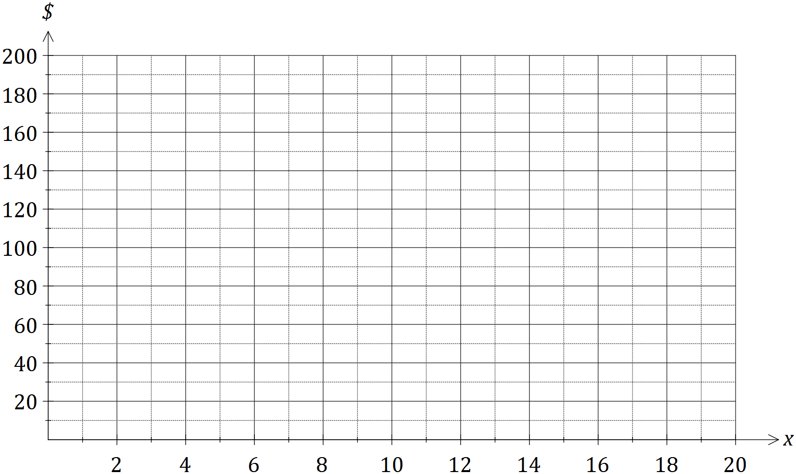

(d) Using your graph, or otherwise, determine the number of pairs of earrings that the student must sell per day in order to break-even at the market. (1 mark)

Question 13 (8 marks)

(a) A young person working in a grocery store has to label shelves with the price per 100 mL of the following bottles of detergent made by the same company:

* a small 450 mL bottle priced at $1.69
* a medium 720 mL bottle priced at $2.99
* a large 1.25 L bottle priced at $4.95

(i) Determine the unit cost for each bottle as required by the store and hence state which size represents the best value. (3 marks)

(ii) The company that made the detergent had just increased the wholesale price of a box of 24 small bottles from $26.40 to $27.30, claiming that the increase was below the current 2.4% annual rate of inflation. Was this claim correct? Justify your answer. (2 marks)

(b) A sum of $5 500 was invested for four years in an account paying 3.75% interest per annum compounded annually.

(i) Calculate the amount in the account at the end of the four years. (2 marks)

(ii) Determine the total interest accumulated over the four years. (1 mark)

Question 14 (7 marks)

A triangular sign has sides of lengths 1.2 m, 1.5 m and 1.8 m.

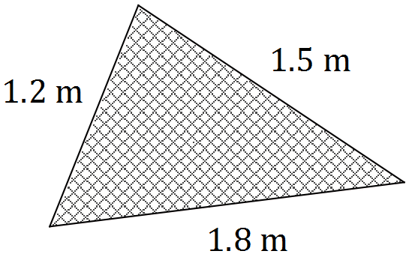

(a) Use Heron's rule to determine the area of the sign. (3 marks)

(b) Show use of trigonometry to determine the size of the angle opposite the side of length 1.8 m. (2 marks)

(c) Use trigonometry to determine the size of the smallest angle in the triangle. (2 marks)

Question 15 (8 marks)

Nasim won $12 500 in a lottery and decided to invest $7 000 in the stock market and spend the rest on a holiday.

(a) Nasim booked a holiday in Egypt, converting $750 Australian dollars (AUD) spending money into Egyptian pounds (EGP) before he left. The exchange rates advertised by his local bank for 1 AUD to EGP were buy: 7.5768 and sell: 5.7723.

(i) Calculate how many Egyptian pounds Nasim took with him, giving your answer to the nearest 10 pounds. (3 marks)

(ii) Nasim returned from holiday with 950 Egyptian pounds. How many Australian dollars would his local bank give him for these pounds? (2 marks)

(b) The cost of the shares Nasim bought at $11.55 each in a company, together with his brokerage fee of $70, came to exactly $7 000. The company forecast it would pay a full year dividend of 35 cents per share.

(i) Determine how many shares Nasim bought in the company. (2 marks)

(ii) What is his expected full year dividend payment? (1 mark)

Question 16 (8 marks)

A solid cone has a base radius of 8 cm and a slant height of 17 cm.

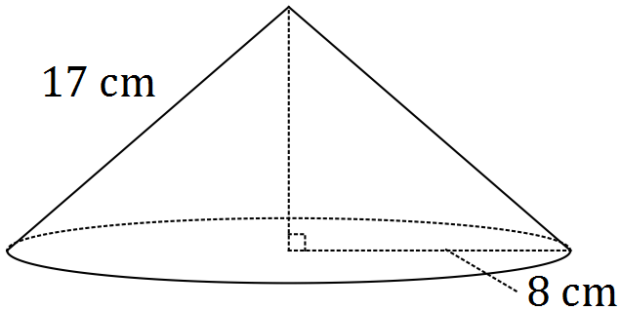

(a) Determine the total surface area of the cone. (2 marks)

(b) Calculate the perpendicular height of the cone. (2 marks)

The solid cone is placed inside an empty cylindrical vase of diameter 16 cm and height 18 cm.

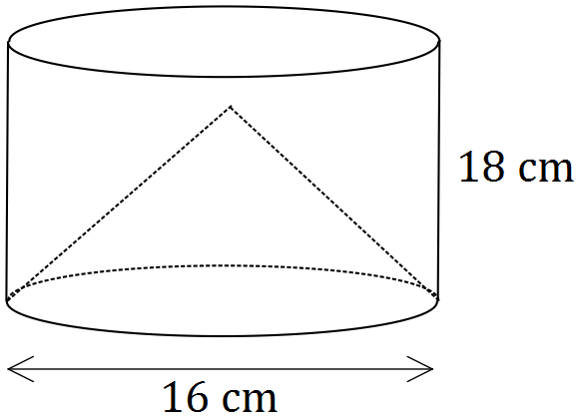

(c) Water is then poured into the vase until it reaches the top. Assuming that the cone does not float, how much water will be required to fill the vase? (4 marks)

Question 17 (11 marks)

An energy saving globe costs $12 to buy and $0.005 per hour to run. A regular globe that delivers the same amount of light as the energy saving globe costs $2.50 to buy and $0.03 per hour to run.

(a) Assuming that neither globe will need to be replaced,

(i) explain why the cost, in dollars, of buying and running one energy saving globe for $x$ hours is given by the expression $12+0.005x$. (1 mark)

(ii) write an expression for the cost, in dollars, of buying and running one regular globe for $x$ hours. (1 mark)

(iii) determine the number of hours for which the cost of buying and running the globes is the same. (2 marks)

(b) It is expected that the regular globe will require replacing every 500 hours.

(i) Complete the table below to show the total cost of buying a regular globe and replacements, and running them in a light for the hours shown. (3 marks)

|  |  |  |  |  |  |
| --- | --- | --- | --- | --- | --- |
| Hours of running time ($x$) | 0 | 250 | 500 | 750 | 1000 |
| Cost of globe, in dollars | 2.50 | - | 2.50 | - | 2.50 |
| Running cost, in dollars | 0 | 7.50 | 15.00 |  |  |
| Total cost in dollars ($C$) | 2.50 | 10.00 | 20.00 |  |  |

(ii) Plot the total cost of buying a regular globe and replacements, and running them for up to 1 500 hours, on the axes below. (4 marks)

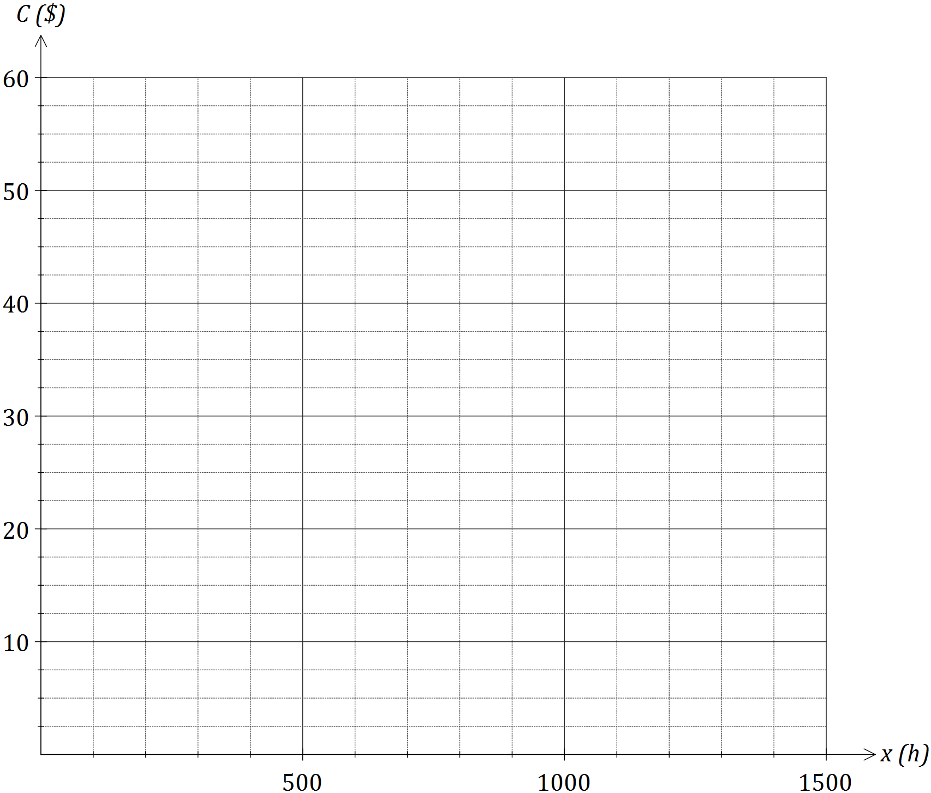

Question 18 (8 marks)

(a) The speeds of cars travelling along a stretch of road with a 60 km/h limit were observed to be normally distributed with mean and standard deviation of 58.5 km/h and 7.5 km/h respectively.

(i) Determine the probability that a randomly selected car travels along the road below the speed limit. (1 mark)

(ii) Determine the probability that a randomly selected car travels along the road within 10 km/h of the speed limit. (2 marks)

(iii) Two percent of cars exceed a speed of $s$ on the road. Determine the value of $s$, giving your answer to the nearest km/h. (2 marks)

(b) A student scored 63% in a geometry test, in which the mean and standard deviation for the class was 55% and 10% respectively.

(i) Calculate the students standard score in the geometry test. (1 mark)

(ii) The mean and standard deviation for the same class in a statistics test was 66% and 20%. If the student achieved the same standard score in both tests, calculate their score in the statistics test. (2 marks)

Question 19 (8 marks)

Student A is 60 m due North of a pole standing on a level playing field. Student B is 45 m due West of the pole. Student C is at a distance of 40 m and on a bearing of 130° from the pole.

(a) Draw a sketch of the positions of the pole and the three students. (1 mark)

(b) Calculate the bearing of student A from student B. (2 marks)

(c) Calculate the distance of student A from student C. (2 marks)

(d) Calculate the bearing of student C from student A. (3 marks)

Question 20 (7 marks)

A machine makes spherical balls of ice. A setting on the machine can change the diameter of the spheres from 1 cm up to 5 cm.

(a) Assuming that water does not change its volume as it turns into ice, determine how many 3 cm diameter spheres of ice the machine could make from 15 litres of water. (3 marks)

*Hint: One litre of water takes up volume of 1 000 cm3.*

(b) The machine made 500 spheres of ice with a diameter of 4 cm and a worker put them all in a rectangular tray on a level table. The tray, in the shape of a rectangular prism, had a length of 62.5 cm, a width of 40 cm and a height of 12.5 cm.

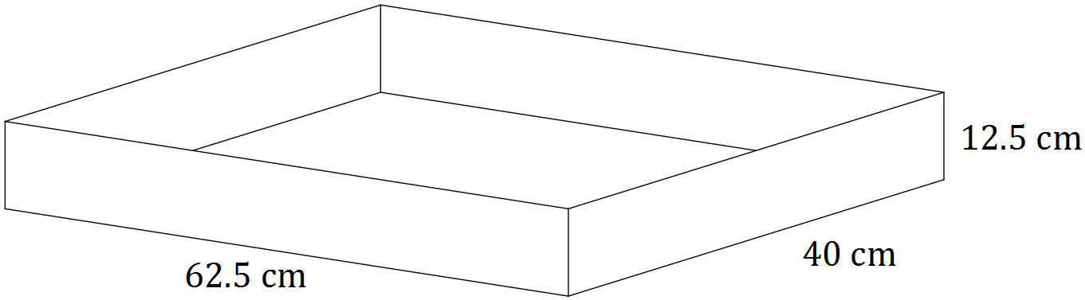

After the cubes had melted back to water, determine the depth of water in the tray.

(4 marks)

Additional working space

Question number: _________

Additional working space

Question number: _________

Additional working space

Question number: _________

© 2016 WA Exam Papers. Kennedy Baptist College has a non-exclusive licence to copy and communicate this paper for non-commercial, educational use within the school. No other copying, communication or use is permitted without the express written permission of WA Exam Papers.